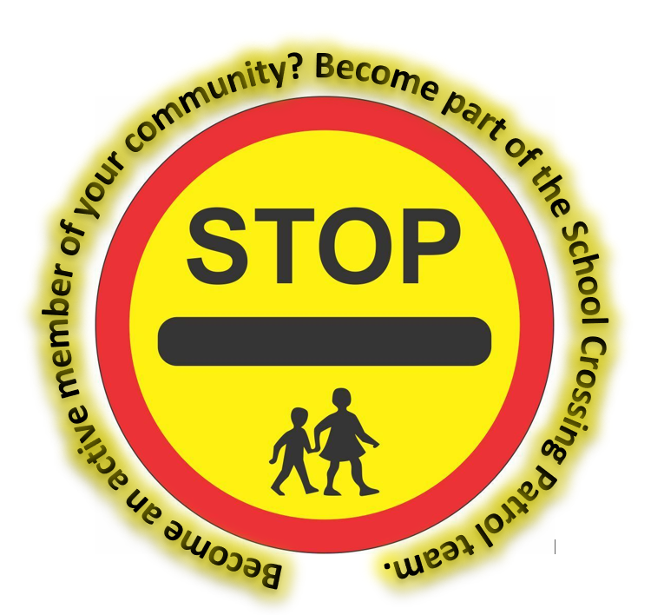
BECOME A SCHOOL CROSSING PATROL AT COURTNEY PRIMARY SCHOOL.

Dear Parents
You can make a difference and be part of your local community by providing a safe crossing point for pupils and parents travelling to and from school, helping to encourage active travel and indepentent journeys for older pupils.
Your school has a School Crossing Patrol site which, at present, is vacant:

Post Details:

Role: School Crossing Patrol – Courtney Primary School.
Site Location: Courtney Road, School Gate.
Times: 8.30am – 9.00am
3.00pm – 3.30pm

Hourly rate: £13.28ph (2026)

Full training and uniform are provided. We are happy to consider part time and/or job share. For further details please contact Martina Byrne-Obee at roadsafetyeducation@southglos.gov.uk or 01454 867802.

