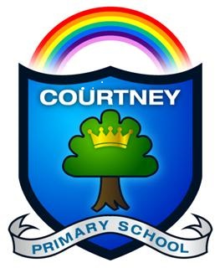
Nurture, Inspire, Flourish

Starting School in 2024

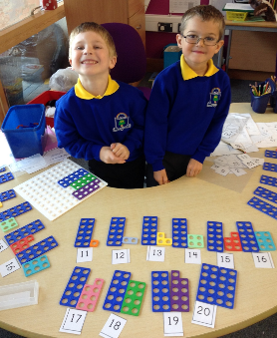
Thank you for your interest in Courtney Primary School. If your child is due to start school in September 2024, (where has the time gone?) please come and visit us at Courtney. Our aim is to give you lots of information to help you understand a bit more about our lovely school, what Reception and future years are like, our amazing community and much more.
If you have any questions, please contact the school office either by:
Telephone: 01454 866670 or Email: office@courtneyps.org.uk
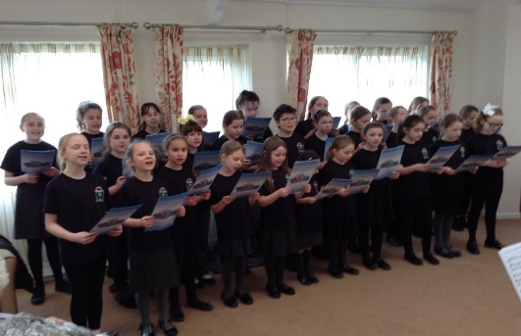
School Tours
- Tuesday 10th October at 2:00pm
- Wednesday 18th October at 6:00pm
- Tuesday 14th November at 6:00pm
- Saturday 2nd December at 9:00am
- Wednesday 6th December at 2:00pm

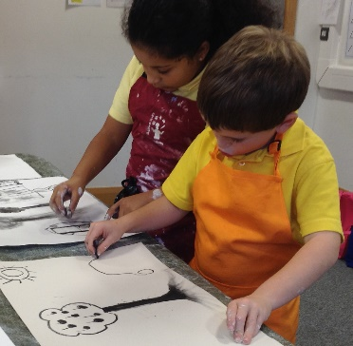
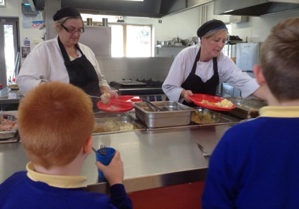
We will need to know in advance numbers so that you are able to have conversations and get to know our community.
To ensure correct numbers, please book a place on these tours by telephoning the school on 01454 866670. This also means that if we have the need, we will be able to plan additional dates in a timely manner. Thank you in advance.
We also have a school Christmas fair run by our motivated Friends Of Courtney Primary School (FOCP) on Saturday 18th November between 12-3pm. All visitors are welcome.
Good luck in what is a very special and important decision and we hope to see you soon!

